|  |  |  |
| --- | --- | --- |
| **SL.NO** | **TOPICS** | **PAGE** |
| **1** | **Abstract** | **1** |
| **2** | **Introduction** | **2** |
| **3** | **History** | **3** |
| **4** | **What is Generative AI** | **4** |
| **5** | **Types of AI Generation Model** | **4** |
| **6** | **What is Stable Diffusion** | **9** |
| **7** | **Workflow of Stable Diffusion Model** | **9** |
| **8** | **Detailed Workflow** | **11** |
| **9** | **Key Features and Advantages** | **14** |
| **10** | **Comparison of AI Generators** | **15** |
| **11** | **Application of Stable Diffusion Model** | **16** |
| **12** | **Ethical Consideration and Challenges** | **18** |
| **13** | **Future Trends and Innovation** | **20** |
| **14** | **Conclusion** | **22** |
| **15** | **References** | **24** |

# **INDEX**

# **Abstract**

Stable Diffusion, a cutting-edge generative AI model, has revolutionized image synthesis by leveraging latent diffusion techniques to produce high-quality, photorealistic images from textual prompts. Unlike traditional generative adversarial networks (GANs), Stable Diffusion operates in a compressed latent space, enabling efficient training and inference while maintaining impressive output fidelity. By combining a variational autoencoder (VAE), a U-Net architecture, and a text encoder (typically CLIP), the model learns to iteratively denoise random noise into coherent visuals guided by user-defined descriptions. This approach not only democratizes creative expression but also finds applications in art, design, and content generation. Despite its advancements, challenges such as ethical concerns, bias in training data, and computational demands remain areas of ongoing research. Stable Diffusion exemplifies the potential of AI-driven image generation to bridge human imagination and machine capability

# **Introduction**

Imagine a world where creativity knows no bounds—where stunning artwork, realistic images, and imaginative visuals can be generated in seconds with just a few words. This is the power of **AI-driven image generation**, an innovation that is transforming digital art, design, and content creation. At the heart of this revolution lies **Stable Diffusion**, a cutting-edge deep-learning model that enables the creation of high-quality images from simple text prompts.

Stable Diffusion operates using advanced neural networks and latent diffusion processes to transform text descriptions into visually striking and detailed images. Unlike traditional image-generation techniques, which require extensive manual effort and graphic design skills, Stable Diffusion democratizes creativity by allowing anyone to generate professional-grade visuals with minimal input. From concept art and advertising to virtual reality and medical imaging, its applications span multiple industries, redefining how we interact with and produce digital content.

However, alongside its groundbreaking potential, AI-driven image generation raises important discussions around ethical concerns, copyright challenges, and biases in AI models. Addressing these challenges requires responsible AI development, regulatory frameworks, and continuous improvements in model fairness and accuracy.

In this seminar, we will explore the core principles behind Stable Diffusion, its underlying technology, real-world applications, and the ethical considerations surrounding AI-generated imagery. Join us on this journey to uncover the future of creativity powered by artificial intelligence.

**History**

### **A Brief History of AI-Driven Image Generation and Stable Diffusion**

AI-driven image generation has evolved significantly over the past decade, transitioning from basic pattern recognition to sophisticated deep-learning models capable of producing highly realistic and artistic visuals.

#### **Early Developments (Before 2014)**

The foundations of AI image generation trace back to traditional computer vision and neural network research. Early AI models focused on tasks like object detection, classification, and basic image transformations. However, these models lacked the ability to generate entirely new images from scratch.

#### **The Rise of Generative Models (2014–2019)**

The introduction of **Generative Adversarial Networks (GANs)** by Ian Goodfellow in 2014 marked a turning point in AI-generated imagery. GANs consisted of two neural networks—a generator and a discriminator—competing against each other to create highly realistic images. Over time, GAN-based models like **StyleGAN** (developed by NVIDIA) enabled the generation of photorealistic human faces and high-quality artwork.

Meanwhile, **Variational Autoencoders (VAEs)** also contributed to generative modeling, though they were less effective than GANs in producing high-resolution images.

#### **The Diffusion Era Begins (2020–Present)**

While GANs revolutionized AI art, they had limitations such as training instability and difficulty generating highly detailed images. This led to the rise of **diffusion models**, which take a fundamentally different approach.

Inspired by thermodynamic diffusion processes, **Denoising Diffusion Probabilistic Models (DDPMs)** emerged as a new technique in AI image generation. Instead of using adversarial networks, these models progressively refine images by reversing a noise process, creating more stable and high-quality outputs.

One of the most notable advancements came in **2022**, when **Stable Diffusion** was introduced by **Stability AI**. Unlike earlier diffusion models, Stable Diffusion was designed to be efficient, open-source, and capable of running on consumer GPUs, making AI-generated art more accessible to the public.

#### **The Impact of Stable Diffusion**

Stable Diffusion democratized AI art by allowing users to generate images from text prompts efficiently. Its impact can be seen in industries such as digital art, advertising, gaming, and even medical imaging. The model's flexibility and open-source nature have fueled widespread innovation, leading to custom fine-tuned versions and integrations with creative tools.

However, with its rise, ethical concerns regarding copyright, data bias, and misuse of AI-generated content have also surfaced. As AI-driven image generation continues to evolve, ongoing research aims to address these challenges while pushing the boundaries of creativity and automation.

### **What is Generative AI?**

Generative AI refers to artificial intelligence models designed to create new content, such as images, text, music, and videos, rather than simply analyzing or classifying existing data. These models learn patterns from large datasets and generate new outputs that mimic the style, structure, or content of the training data.

In the context of image generation, generative AI enables the creation of highly realistic and artistic visuals from scratch. It powers applications in digital art, game design, content creation, and even scientific simulations. The core of generative AI lies in machine learning techniques such as neural networks, which allow the AI to produce complex and high-quality results.

### **Types of AI Image Generation Models**

#### **Generative Adversarial Networks (GANs)**

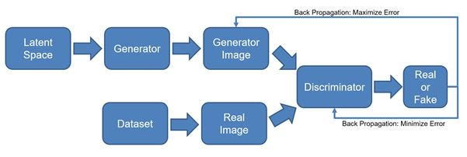

Introduced by Ian Goodfellow in 2014, **Generative Adversarial Networks (GANs)** consist of two competing neural networks:

* **Generator:** Creates new images based on random noise or input data.
* **Discriminator:** Evaluates whether an image is real (from training data) or fake (generated).

Through continuous competition, the generator improves over time, producing highly realistic images. GANs have been widely used in AI-generated art, deepfake technology, and content synthesis. Notable GAN-based models include **StyleGAN** and **BigGAN**.

#### **Variational Autoencoders (VAEs)**

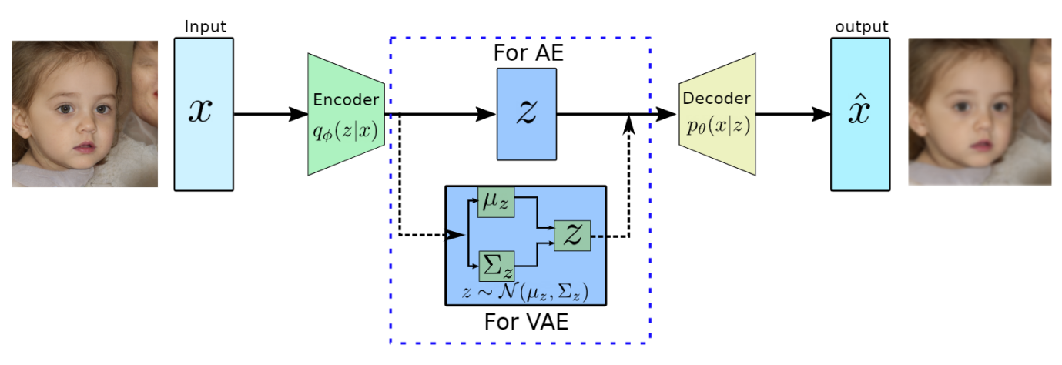

**Variational Autoencoders (VAEs)** are another type of generative model that learns to encode images into a compressed latent space and then reconstruct them. Unlike GANs, VAEs focus on structured representation learning, meaning they are better at generating smooth variations of data but struggle to produce highly detailed and realistic images.

VAEs are commonly used for tasks like image compression, denoising, and latent space exploration in AI art generation. While they are not as popular as GANs or diffusion models for high-resolution image synthesis, they play a crucial role in AI-driven generative research.

#### **Diffusion Models**

1. 

**Diffusion models** are a newer class of generative AI models that have gained popularity due to their ability to generate highly detailed and diverse images. These models work by:

1. **Adding Noise:** Gradually introducing noise into an image until it becomes completely unrecognizable.
2. **Denoising Process:** Using a deep-learning model to reverse the noise process and reconstruct a clear, high-quality image.

### **Working Mechanism of Diffusion Models**

Diffusion models, including Stable Diffusion, operate based on a two-step process:

1. **Forward Process (Noise Addition)**

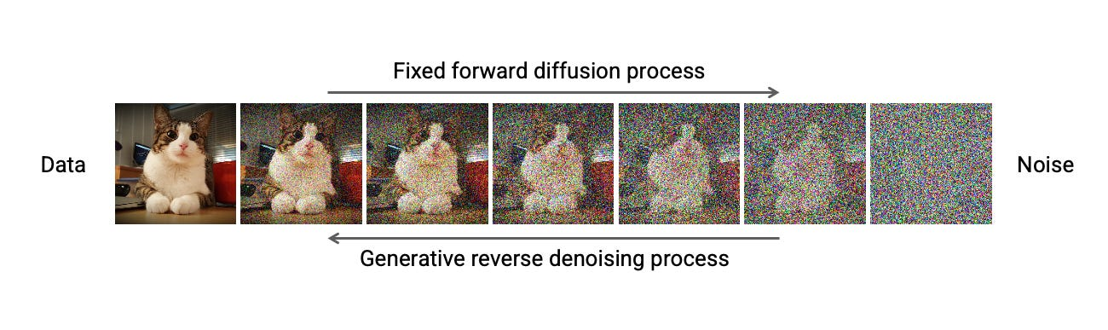

* 1. The model takes an image and gradually **adds noise** over multiple steps until it becomes completely random (like static noise).
  2. This process helps the model learn how images degrade, enabling it to reverse the process effectively.

1. **Reverse Process (Denoising & Generation)**

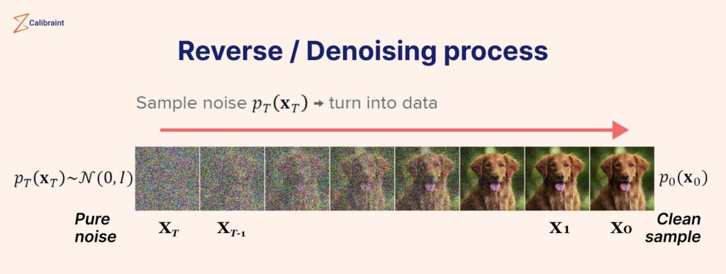

* 1. The model starts with pure noise and **reverses the process step by step**, gradually reconstructing a meaningful image.
  2. This is achieved using a trained neural network that predicts the noise at each step and removes it to generate a realistic image

### **What is Stable Diffusion?**

Stable Diffusion is an advanced AI-driven image generation model that uses **latent diffusion techniques** to create high-quality images from text prompts. Developed by **Stability AI** and released in 2022, Stable Diffusion is designed to be **efficient, open-source, and accessible** to users with consumer-grade GPUs.

Unlike traditional image generation models, Stable Diffusion leverages a **text-to-image** approach, allowing users to input descriptive prompts and receive visually coherent images. It is widely used in digital art, gaming, advertising, and AI-driven design applications due to its versatility and high-quality output.

**Workflow of a Stable Diffusion Model**

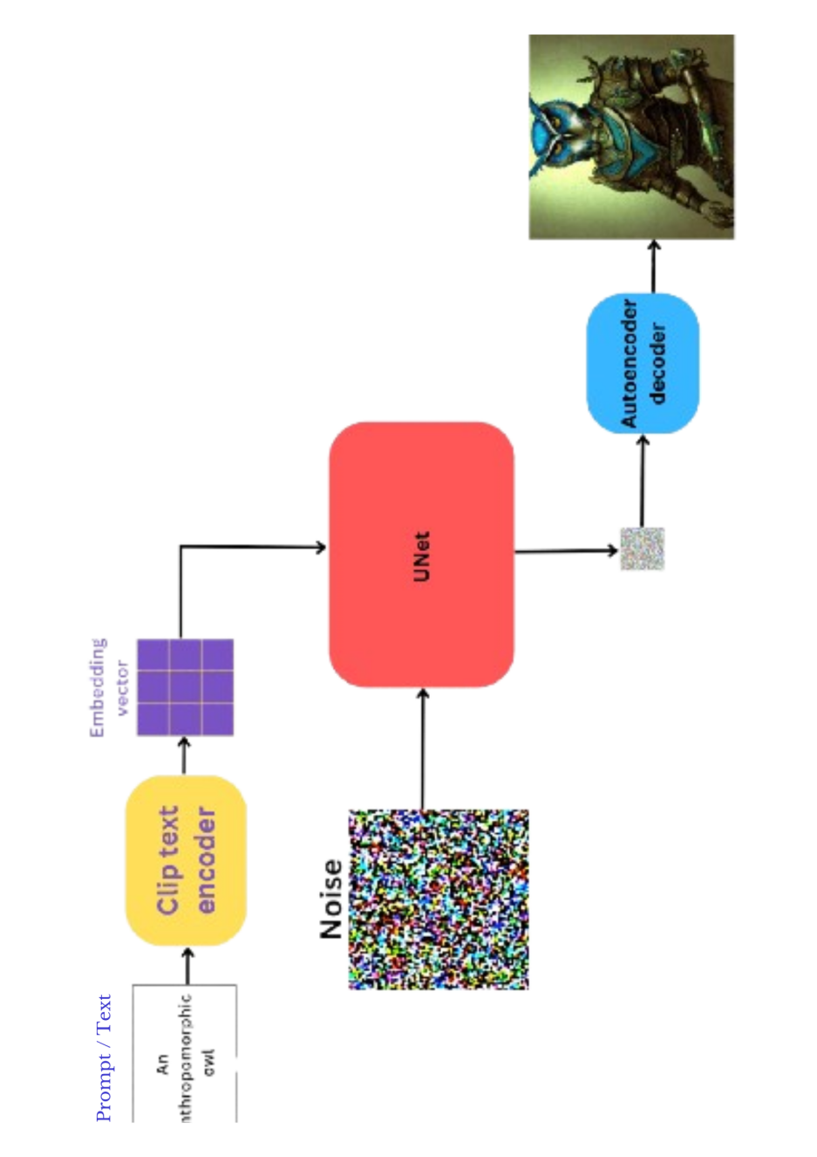

### **Text-to-Image Generation Process**

The **Text-to-Image** process in Stable Diffusion involves transforming a textual prompt into a visually coherent image using **diffusion techniques**.

#### **Step-by-Step Breakdown:**

**Tokenization of Text Input**

* 1. The input text prompt is processed by a **text encoder (CLIP)**, which converts words into **latent space embeddings** (vector representations).

**Noise Initialization**

* 1. The model starts with a **random noise image** in the latent space.

**Latent Space Processing (Denoising)**

* 1. The noise is progressively refined by a **U-Net model**, which removes noise step-by-step based on the text embeddings.
  2. **Scheduler algorithms (DDIM, PNDM, etc.)** help control the denoising process for better output quality.

**Image Reconstruction**

* 1. After multiple iterations, the model **generates a final image** that aligns with the text prompt.

**Output & Refinement**

* 1. The generated image can be saved or further refined using **upscalers and editing tools**

**Detailed Workflow**

1. **Prompt Processing**

A language model that takes in a text prompt and turns it into a form that it can use to guide image generation.

1. **Tokenization : Convert words into token IDs.**
2. **Embedding Layer :Convert token IDs into vectors.Capture relationships between words**
3. **CLIP Text Encoder (Contrastive Language-Image Pretraining)**
4. **Random Noise Image Generation**

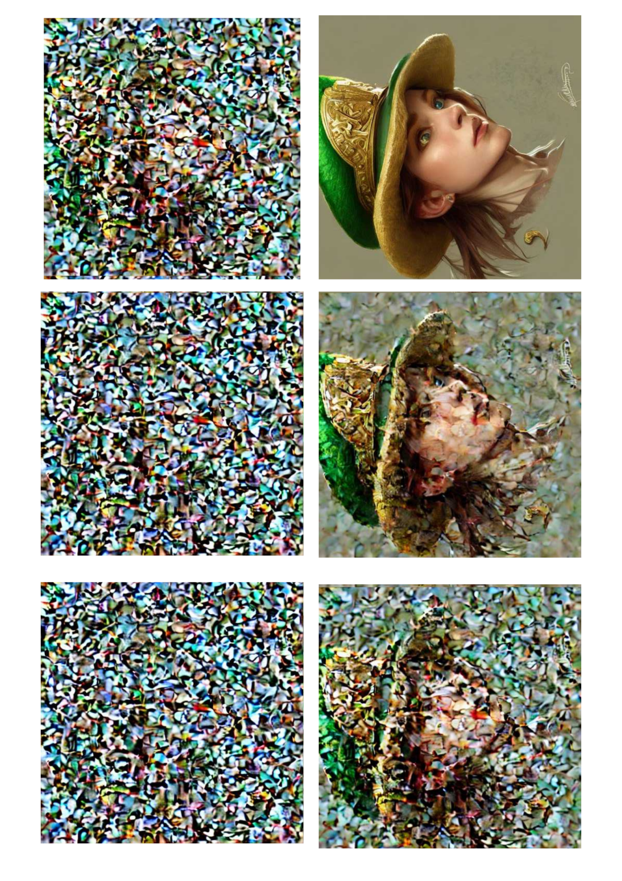

Starting point for the image generation process.Inorder to make image from noise, model is trained to generate them by adding noise to an image (forward) and then tries to remove the noise (reverse).Allows the denoising process to progressively shape the image into something meaningful.

1. **U-NET Architecture**



1. Net is a **convolutional neural network (CNN)-based architecture** used in **Stable Diffusion** for the denoising process. It plays a crucial role in transforming noisy latent representations into meaningful images.



#### **1. Noise Input & Latent Representation**

* The process starts with a **random noisy latent tensor** (compressed image representation).
* This latent space is **lower-dimensional** compared to actual image pixels, making the model computationally efficient.

#### **2. Downsampling Path (Encoder)**

* The **encoder** consists of multiple **convolutional layers and attention mechanisms** that progressively extract hierarchical features.
* Each layer **reduces the spatial size** while increasing feature depth, capturing essential details.
* Skip connections **preserve fine-grained details** for later reconstruction.

#### **3. Bottleneck (Lowest Latent Representation)**

* The deepest part of U-Net, where **global context understanding** occurs.
* Uses **self-attention mechanisms** (like Cross-Attention layers) to **align features with the text prompt embeddings** (from CLIP).
* This ensures that the final output **matches the textual description accurately**.

#### **4. Upsampling Path (Decoder)**

* The **decoder** reconstructs the image by gradually removing noise.
* **Transposed convolutions** increase the spatial size while combining details from skip connections.
* Each step progressively **removes artifacts** and sharpens the image.

#### **5. Final Image Reconstruction**

* The output is a **denoised latent representation** that is then passed through a **VAE (Variational Autoencoder) decoder**.
* This converts the latent tensor back into **a high-quality image**.

### **Key Features and Advantages of Stable Diffusion**

* **Open-Source & Customizable** – Unlike proprietary models (e.g., DALL·E, MidJourney), Stable Diffusion is freely available for modification and fine-tuning.
* **Efficient & Lightweight** – Runs on consumer GPUs with as little as **8GB of VRAM**, making it more accessible than traditional AI models.
* **Text-to-Image & Image-to-Image Generation** – Users can create images from text descriptions or enhance/edit existing images.
* **High-Resolution & Fine Details** – Generates high-quality visuals with intricate details, making it suitable for professional design and digital art.
* **Privacy & Control** – Since it can be run locally, users retain control over their generated content without relying on cloud services.

# **Comparison of AI Image Generators**

|  |  |  |  |  |
| --- | --- | --- | --- | --- |
| Feature | Stable Diffusion | DALL·E (OpenAI) | MidJourney | GANs (StyleGAN) |
| Open Source | ✅ Yes | ❌ No | ❌ No | ✅ Yes |
| Runs Locally | ✅ Yes | ❌ No (Cloud-based) | ❌ No (Cloud-based) | ✅ Yes |
| Text-to-Image | ✅ Yes | ✅ Yes | ✅ Yes | ❌ No |
| Image Editing | ✅ Yes (Inpainting, Outpainting) | ✅ Limited | ❌ No | ❌ No |
| Detail & Realism | ✅ High | ✅ High | ✅ Very High | ✅ High |
| Computational Requirements | Moderate | High (Cloud-based) | High (Cloud-based) | High |

### **Applications of Stable Diffusion**

Stable Diffusion has revolutionized various industries by enabling AI-driven image generation with high-quality, realistic outputs. Below are some key applications across different domains:

### **5.1 AI in Digital Art and Content Creation**

* Artists use Stable Diffusion to generate **unique and high-resolution artworks**, often blending different styles.
* Enables **concept art creation** for movies, books, and video games.
* Used in **comic book illustrations**, helping artists visualize complex scenes.
* Enhances **photo editing and manipulation** with AI-powered tools for inpainting and outpainting.

**Example:** Artists use Stable Diffusion to create digital paintings that blend realism and fantasy styles.

### **5.2 AI in Gaming and Virtual Reality**

* Stable Diffusion helps in generating **game assets** like textures, characters, and backgrounds.
* Used to create **procedural game environments** for more immersive worlds.
* Assists in designing **concept art for game characters and levels** before actual development.
* Helps generate **AI-powered avatars and NPCs** with realistic visual styles.

**Example:** Developers use AI-generated textures and environments in open-world games, reducing manual workload.

### **5.3 AI in Advertising and Marketing**

* Companies use AI-generated images for **personalized advertisements** based on user preferences.
* Brands can create **custom marketing visuals** without hiring large design teams.
* AI enables **automated content generation**, producing high-quality promotional materials quickly.
* Assists in generating **product mockups** for e-commerce businesses.

**Example:** A fashion brand uses Stable Diffusion to create ad visuals featuring AI-generated models wearing new collections.

### **5.4 AI in Medical Imaging and Research**

* AI enhances **medical image analysis** by generating synthetic yet realistic images for training models.
* Helps in **disease diagnosis** by improving the quality of MRI and CT scan images.
* Aids in **drug discovery** by generating molecular visualizations.
* Used in **data augmentation** for training medical AI models, improving accuracy.

**Example:** AI-generated synthetic X-ray images help train deep learning models for detecting lung diseases.

### **5.5 AI in Fashion and Design**

* Designers use AI-generated concepts for **clothing and accessories**.
* Helps in **virtual try-on experiences**, allowing customers to see AI-generated outfits before purchasing.
* Used to create **fabric patterns and textures**, reducing manual design work.
* Assists in **fashion trend prediction** by analyzing AI-generated designs.

**Example:** A designer inputs a prompt to generate futuristic clothing styles for a new collection.

### **Ethical Considerations and Challenges in AI-Driven Image Generation**

As AI-driven image generation, including Stable Diffusion, becomes more widespread, several ethical concerns and challenges emerge. These issues must be addressed to ensure responsible AI usage while fostering innovation.

### **7.1 Copyright and Ownership Issues**

* AI-generated content raises **questions of ownership**—does the creator of the prompt, the model developer, or the AI itself own the generated image?
* Copyright laws in many countries **do not currently recognize AI-generated art** as legally protected.
* Companies training AI models on large datasets may use copyrighted materials without proper consent, leading to **legal disputes over data sourcing**.
* Artists and photographers **express concerns over AI using their work without permission**, impacting their livelihoods.

**Example:** Lawsuits have been filed against AI companies for training models on copyrighted images without consent.

### **7.2 Bias and Ethical Concerns in AI Art**

* AI models can inherit **biases from their training data**, leading to unfair representations or stereotypes in generated images.
* There are **concerns over underrepresentation** of certain cultures or ethnicities in AI-generated content.
* Some AI-generated images may inadvertently **reinforce harmful stereotypes** or display gender and racial bias.
* Ethical AI development requires **diverse and inclusive datasets** to minimize bias in generated images.

**Example:** Some AI-generated portraits have been criticized for favoring Western beauty standards, highlighting bias in training data.

### **7.3 Misuse and Deepfake Concerns**

* AI image generation can be misused for **creating deepfakes**, leading to misinformation, identity theft, or reputation damage.
* AI-generated fake images can be used in **propaganda, political manipulation, and cybercrimes**.
* **Malicious actors** can create misleading content, blurring the line between real and fake visuals.
* Platforms need **content moderation strategies** to detect and flag AI-generated misinformation.

**Example:** AI-generated deepfake images of public figures have been used in fake news campaigns.

### **7.4 Addressing AI-Generated Content Regulation**

* Governments and organizations are working on **legal frameworks** to regulate AI-generated content.
* Companies developing AI models must implement **ethical guidelines**, including watermarking AI-generated images.
* Transparency in AI-generated content is necessary to ensure **users are aware when an image is AI-created**.
* Striking a balance between **regulation and creative freedom** is key to fostering responsible AI innovation.

**Example:** Some AI-generated images now include metadata or watermarks to indicate their synthetic origin.

### **Future Trends and Innovations in AI-Driven Image Generation**

AI-driven image generation is evolving rapidly, bringing groundbreaking advancements in art, design, and media. As technology continues to improve, we can expect significant transformations in the way AI and humans collaborate in creative fields.

### **8.1 Advancements in AI-Generated Art**

* **Improved Realism and Creativity**: Future AI models will generate even more **realistic and detailed images**, with enhanced textures, lighting, and artistic styles.
* **Personalized AI Art**: AI models will adapt to individual artistic styles, allowing users to create **customized artwork** based on their preferences.
* **Real-Time Image Generation**: AI will soon enable **real-time interactive image creation**, allowing users to modify images instantly using text prompts or gestures.
* **Multimodal AI Models**: Future AI systems will integrate text, audio, and video generation, **blurring the lines between different media formats**.

**Example:** AI models like Stable Diffusion 3 and DALL·E 4 may offer more control over artistic elements, making AI-generated content indistinguishable from human-made art.

### **8.2 AI and Human Collaboration in Creativity**

* AI will act as a **co-creator**, assisting artists, designers, and filmmakers in generating ideas and refining their work.
* AI-powered tools will allow artists to **iterate faster**, reducing the time needed for concept creation and prototyping.
* **Hybrid workflows** will emerge where humans provide creative direction, while AI assists with execution.
* AI will enhance **collaborative projects**, where multiple users can interact with AI to create shared artistic visions.

**Example:** Artists might use AI to generate base sketches or textures and refine them manually, leading to **a fusion of human creativity and AI assistance**.

### **8.3 The Role of AI in the Future of Design and Media**

* **Automated Design Processes**: AI will streamline the **graphic design and advertising** industry by generating logos, layouts, and marketing materials effortlessly.
* **AI in Film and Animation**: AI-driven image generation will be integrated into **VFX and animation**, reducing production costs and time.
* **AI-Generated Virtual Influencers**: AI-generated personalities and digital avatars will be used in **social media, gaming, and branding**.
* **Ethical AI in Media**: As AI-generated content becomes mainstream, regulations and standards will be necessary to **ensure ethical and responsible AI usage**.

**Example:** AI-powered animation tools will allow small studios and independent creators to produce high-quality animations with minimal resources.

### **Conclusion**

AI-driven image generation, particularly through models like Stable Diffusion, has transformed the landscape of digital creativity. This seminar explored the fundamental concepts, mechanisms, applications, and ethical challenges associated with AI-generated art. As technology continues to evolve, its role in various industries will only grow, shaping the future of media, design, and human-AI collaboration.

### **9.1 Summary of Key Insights**

* **Generative AI** has revolutionized the way images are created, enabling automation and enhanced creativity.
* **Stable Diffusion** and other AI models use diffusion processes to generate high-quality, detailed, and diverse images.
* **Applications of AI-driven image generation** span across digital art, gaming, marketing, medical imaging, and more.
* **Ethical concerns** such as copyright, bias, and misuse (e.g., deepfakes) must be addressed to ensure responsible AI development.
* **Future innovations** will improve realism, interactivity, and human-AI collaboration in creative fields.

### **9.2 Potential of AI Image Generation**

* AI image generation **democratizes creativity**, making artistic tools accessible to non-artists.
* AI-driven design will **accelerate workflows** in industries like gaming, fashion, and marketing.
* Future AI advancements will enable **personalized, real-time, and interactive image creation**.
* Collaboration between AI and human creators will lead to **new forms of artistic expression**.

### **9.3 Final Thoughts on the Future of AI Art**

As AI-generated art becomes more sophisticated, its impact on creative industries will be profound. However, ethical concerns, regulation, and human oversight are essential to ensure responsible use. The future of AI art lies in balancing **innovation with ethical considerations**, allowing AI to serve as an empowering tool for artists rather than a replacement.

AI’s role in image generation is not just about automation—it is about **augmenting human creativity**, expanding artistic possibilities, and shaping a new era of digital expression.

### **References**

* **Ho, J., Jain, A., & Abbeel, P. (2020).** Denoising Diffusion Probabilistic Models. NeurIPS. [https://arxiv.org/abs/2006.11239](https://arxiv.org/abs/2006.11239" \t "_new)
* **Ramesh, A., Pavlov, M., Goh, G., et al. (2021).** Zero-Shot Text-to-Image Generation. OpenAI. [https://arxiv.org/abs/2102.12092](https://arxiv.org/abs/2102.12092" \t "_new)
* **Rombach, R., Blattmann, A., Lorenz, D., et al. (2022).** High-Resolution Image Synthesis with Latent Diffusion Models. CVPR. [https://arxiv.org/abs/2112.10752](https://arxiv.org/abs/2112.10752" \t "_new)
* **Goodfellow, I., Pouget-Abadie, J., Mirza, M., et al. (2014).** Generative Adversarial Networks. NeurIPS. [https://arxiv.org/abs/1406.2661](https://arxiv.org/abs/1406.2661" \t "_new)
* **Kingma, D. P., & Welling, M. (2013).** Auto-Encoding Variational Bayes. ICLR. [https://arxiv.org/abs/1312.6114](https://arxiv.org/abs/1312.6114" \t "_new)
* **OpenAI (2023).** DALL·E: Creating Images from Text. [https://openai.com/dalle](https://openai.com/dall-e" \t "_new)
* **Stability AI (2022).** Stable Diffusion: Open-Source Text-to-Image Generation Model. <https://stability.ai/blog/stable-diffusion>
* **Patel, K. (2023).** Applications of AI in Digital Art and Media. Journal of AI Research, 45(2), 120-134.
* **Vincent, J. (2022).** How AI Image Generators Are Changing the Art World. The Verge. [https://www.theverge.com](https://www.theverge.com" \t "_new)
* **Knight, W. (2022).** The Rise of AI-Generated Art and Its Implications. MIT Technology Review. [https://www.technologyreview.com](https://www.technologyreview.com" \t "_new)